Eventi
Use Case Specification

Submitted to:

Asst. Prof. Ma. Rowena C. Solamo
Faculty Member
Department of Computer Science
College of Engineering
University of the Philippines, Diliman

Submitted by:
Dimaano, Aaron Diego I.
Lopez, Matthew S.
Torres, Jacob Angelo V.

In partial fulfillment of academic requirements
for the course
CS 191 Software Engineering I
of the
1st Semester, AY 2014-2015
Unique Reference:
The documents are stored in https://github.com/Tom-2013-06417/CS191-192_Event_Sharing/tree/master/02-Requirements%20Engineering.
Link to this document: https://github.com/Tom-2013-06417/CS191-192_Event_Sharing/blob/master/02-Requirements%20Engineering/1%20-%20User%20is%20unable%20to%20use%20the%20site%20or%20its%20functionalities.pdf.

Document Purpose:
[What is the purpose of the document?]

Target Audience:
To our project client and adviser, our fellow 191 classmates, and our future selves when they need to refer back to this document.

Revision Control

Revision Date | Person Responsible | Version  Number | Modification
09/18/15 | Dimaano, Diego  Lopez, Matthew  Torres, Jacob | 1.0 | Initial Document

Use-Case Name: [Name of Use Case: eg. 1.0 Applicant is assigned to a squad.]

Description: [Write the 3 to 5 sentences that describes the Use Case.]

Preconditions: [If there are any, write the preconditions. Otherwise, simply type NONE.]

Flow of Events:

Scenario Name | Description
Scenario 1 (Basic Flow)  Applicant is assigned to the training squad. | 1. Selection committee gets application form.  2. Club staff prepares try-out area.  3. Selection committee evaluates applicant's performance in mock try-outs.  4. If applicant needs training, he is assigned to the training squad.  5. Club staff keeps the application forms in the appropriate files.
Scenario 2  Applicant is assigned to the competing squad. | 1. Selection committee gets application form.  2. Club staff prepares try-out area.  3. Selection committee evaluates applicant's performance in mock try-outs.  4. If applicant plays excellent, he is assigned to the competing squad.  5. Club staff keeps the application forms in the appropriate files.

Activity Diagram of the Flow of Events:

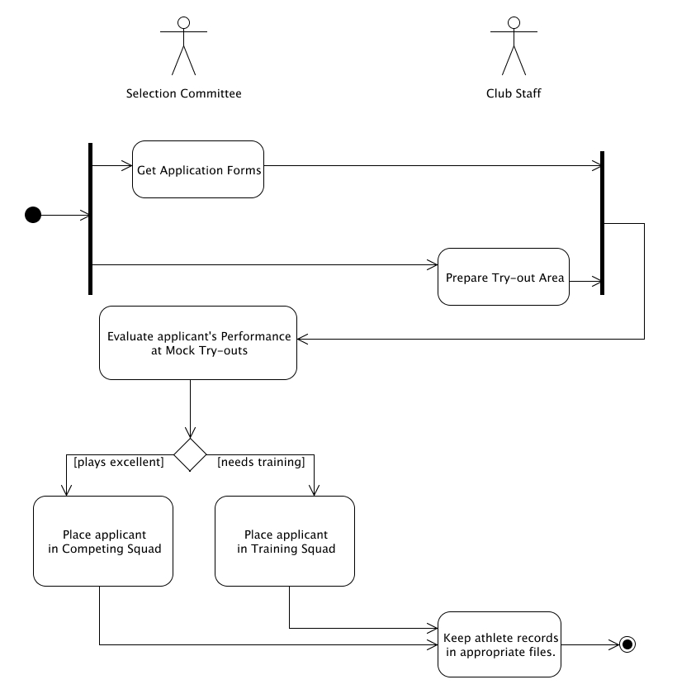

Postcondition: [If there are any, write them here. Otherwise, type in NONE.]

Relationships: [If there are any, write them here. Otherwise, type in NONE.]

Special Requirements:
[If there are any, write them here. Otherwise, type in NONE.]

